**Hong Kong Institute of Vocational Education (Tsing Yi)**

**Department of Information Technology**

**Higher Diploma in Software Engineering**

**ITP4506 HCI & GUI Programming**

**(2021/2022)**

**Group 9**

**System Documentation**

Members:

|  |  |  |  |
| --- | --- | --- | --- |
| Student ID | Name | Contribution | Signature |
| 200099268 | Ngai Pan | 50% |  |
| 200090262 | Ng Chun Yin | 50% |  |

**Abstract**

An innovative Secondary school is going to provide a new service called "Attendance Online " to the teachers and students.

The aims of the system are

* + 1) to allow teachers to upload students’ attendance records,
  + 2) to allow students to search and view the attendance records,
  + 3) to allow school admin and teachers to generate students’ attendance reports

Table of Contents

2 User Analysis 6

2.1 User characteristics 6

2.1.1 User Roles 6

2.1.2 Learning style 8

2.1.3 Tool preferences 8

2.1.4 Physical differences 9

2.1.5 Cultural differences 10

2.1.6 Knowledge of job 10

2.1.7 Application familiarity 11

2.2 Techniques used for observing and listening to users 12

2.2.1 Think aloud 12

2.2.2 Talk right after 12

2.2.3 Cueing recall with videotape 13

2.2.4 Focus groups 13

2.2.5 Mailed/Online surveys 14

2.3 Environment Analysis 15

2.4 Recruiting User 16

2.5 Task Analysis (HTA) 17

3 Mental Model 41

3.1 Login Page 41

3.2 Home page 42

3.3 Admin 43

3.3.1 Account Management 43

3.3.2 Class Allocation 45

3.3.3 Searching & reporting 47

3.3.4 Attendance Management 50

3.4 Student 53

3.4.1 Account Management 53

3.4.2 Class Allocation 54

3.4.3 Searching and reporting 55

3.4.4 Attendance Management 57

3.4.5 Learning center 58

3.5 Teacher 60

3.5.1 Account management 60

3.5.2 Class Allocation 62

3.5.3 Searching and Reporting 64

3.5.4 Attendance Management 66

3.5.5 Learning center 67

4 Affordance 72

4.1 Login Page 72

4.2 Home page 73

4.3 Admin 74

4.3.1 Account Management 74

4.3.2 Class Allocation 74

4.3.3 Searching & reporting 74

4.3.4 Attendance Management 75

4.3.5 Learning Center 75

4.4 Student 77

4.4.1 Account Management 77

4.4.2 Class Allocation 77

4.4.3 Searching and reporting 77

4.4.4 Attendance Management 77

4.4.5 Learning center 78

4.5 Teacher 79

4.5.1 Account management 79

4.5.2 Class Allocation 79

4.5.3 Searching and Reporting 79

4.5.4 Attendance Management 80

4.5.5 Learning center 80

5 Content Organization 81

5.1 Organizational schemes 81

5.2 Organizational structures 81

5.3 Research and interview techniques 81

6 Visual Organization 82

6.1 Proximity 82

6.2 Alignment 82

6.3 Consistency 83

6.4 Contrast 84

7 Navigation 85

7.1 Navigational Design 85

7.2 Navigational Elements 85

# User Analysis

## User characteristics

We will carry out the User Analysis process before you start coding our system.

### User Roles

There are 3 roles in our system, which is school admin, class teacher and student.

**School Admin:** Admin have the highest authority, can do many managements action, and see more things than other roles.

**Class Teacher**: Class teacher can manage their classes and students.

**Student:** Student can check their status (class, attendance). Parents are also considered to use the system with this role.

We will briefly explain the operations those roles below:

Account management

School Admin:

Admin can view and search all user information, create accounts for all the school members and enable/disable user accounts.

Class Teacher:

Teacher can search, edit and view students’ information of their classes, view and edit their personal account information including change password

Student:

Student can view and edit their personal detail including change password

Class allocation

School Admin:

School admin can set the class archive to allow new classes creation and edit class information.

Class Teacher:

Class Teacher can create classes, and edit its information, then teacher can manage who students are in the classes. Also, teacher can view the class detail and student list of the class.

Student:

Student can view their class allocation status including current year and previous years.

Searching and reporting

School Admin:

School admin can search students’ attendance record as a school, class and an individual. Generate school report for the class and students’ status (e.g., attendance record) for the current school year.

Class Teacher:

Class teacher can search students’ attendance record as a class and an individual student in the current year. Also generating class reports for the for the class and students’ status (e.g., attendance record).

Student:

Student can search their attendance records by year, month et cetera.

Attendance Management

School Admin:

School admin and record students’ sick record.

Class Teacher:

Class teacher can record the attendance status of students, endorse students’ sick leave certificate and record students’ personal leave.

Student:

Student can upload their sick leave certificate.

Learning center

School Admin:

School admin can manage the “Learning Center” including the testes. Also manage learning materials of all classes and manage the useful online tools of the “Learning Center”.

Class Teacher:

Class teacher can make some test for students, manage, and give learning materials to students and use some useful online tools.

Student:

Student can do some test that arranged by their teacher, see the learning materials uploaded by teacher and use some useful online tools.

### Learning style

In this part, we will talk about the users’ habits of learning.

There are two styles of learning, do-then-read and read-then-do. For the do-then-read, user will like to act without reading the description or menu, using their instinct to do what they want. And the read-then-do, user will follow the procedure to act.

After consideration, we think our users (teacher, admin, student) have a lot of experience using website, especially for student, which will make them familiar with most of the online system, so that their learning style would be mostly do-then-read. As a result, our website should have an intuitive design, such as adding some graphic on the website to let user know what the function is about in one eye, there would be less instructions.

### Tool preferences

In this part, we will discuss about the knowledge of users using controls.

Considering our user is familiar with online system as we motioned, we will choose some common controls for the system. And the online system is PCs based, we will think user will use the online system with keyboard and mouse.

Based on the discussion above. Here are some common controls we think user knows how to use and we will use in our online system:

Control: buttons

Selection: check box, radio buttons, drop down list

Data input: slide bar, textbox, date picker

Focus current action: dialog

The reason we use dialog to focus users’ current action is because it can let user continue to perform their action in the same page without opening other page, it avoids too much pages is opened, it avoids making user confused and lost themselves in the system.

As we are using mouse to control the system, the buttons can be smaller, since mouse can have a more precise control, unlike touch screen user.

### Physical differences

In this part, we will discuss about the knowledge of users using controls.

The abilities among different people may be different.

Ages

For the age of the user, there are different needs. Some teachers and admins’ age are old, it means that their eyes may not functions normally, so that the font sizes of the website should be bigger. As for the student, they are teenagers, their eyes should function normally, which means that they can see things clearly, and teenagers loves the font sizes to be smaller, they can see more things at the same time and see the information quickly, so the font sizes of the website should be smaller.

As a conclusion, for the school admin and class teacher role, they need a bigger font size, and for student small font size is preferred.

Sex

As a mixed-sex education school, there would be nearly same number of man/boy and woman/girl using the system. Considering this, we think our online system should be neutral, the UI, color and words font should be both suitable for both sexes.

### Cultural differences

In this part, we will discuss about the cultural differences of user.

**Education and Profession** (reading level and specialized vocabularies)

Class teacher and School Admin

Class teacher and school admin are both professional, have a higher education background, they must have at least held a bachelor degree, so that their English reading level must not be bad and they should know a lots of specialized vocabularies, also, their English level should be good, we can use some hard specialized vocabularies in their pages in the system.

Student

Student have lower education background, they are still learning and practicing their reading skill, so that their reading level are limited. And are still student, not supposed to know a lots of specialized vocabularies, we need to use simple words in the pages for student, for them to more easily understand the operation of the website. Also, our secondary school is an international secondary school, we assumed that all students have basic English education but their Chinese is weak.

As a conclusion, the website should be English based. For student, the usage of words in their pages should be simple and easy to understand for them. As for the school admin and class teachers, their pages can use some specialized vocabularies.

### Knowledge of job

Both three roles use computer frequently and mainly for work.

School Admin are considered to visit the website system five days a week, to take some sick leave record, and some time review on some report.

Class Teacher are considered to visit the website system five days a week, at least for taking attendance.

Student is considered to visit the website system at least one time a week to check some status or visit “Learning Center”.

### Application familiarity

There are two types of users in here, novice and expert. Novice may face a frightening unknown, timid, nervous and in no mood to explore the website, also, they are impatient to learn how to use the website. And for the expert, they can diagnose simple problems and perform a much more complex tasks than the novice, they can also diagnose complex problem and has a mental model of the web system.

Novice

Class teacher should be a novice, because most of the teacher are old, they have less experience to use new technology or using a website.

Expert

School admin should be an expert, because of their profession, they should know how to use most of the website system, even they are new to the system.

Student are also considered as an expert, the teenager nowadays nearly all of them have an electronics device, they should have a lot of experience of using online system, such as Facebook.

## Techniques used for observing and listening to users

In this part, we will observe the school operation and listening to the future users before we implement the system.

### Think aloud

School principal are invited to express their views of functions of the system. Considering a principal of school knows the operations of the school very well, and principal have an office where the principal will stay there a long time which is easy to meet him, we decided to arrange an interview with the principal.

We asked that how an online attendance reporting function reduce workload, principal think that it is important to have an online attendance report function because every evening principal have to review the attendance status of that day, principal will receive the attendance paper (fill up by teacher) of each class (24 total) and need to check them on by one, it is very inconvenience, a quick overview is preferred. Also, principal also mention that if there is a yearly school attendance report can help him to manage the school more efficiently.

As a conclusion, principal think that online attendance reporting can help him reduce workload, and we should add a yearly school attendance report function to help principal to manage the school.

### Talk right after

We have gone to the classroom in one morning, to look at how teacher tick attendance every morning, since it is better not to stop teachers’ work, we will ask her questions after her job is finished.

At every morning 8:00am, class teacher has to take out a paper with all the name of students, teacher will write down an English letter to present the students’ attendance status.

Here is the status we have seen teacher filling:

|  |  |
| --- | --- |
| Letter | Status |
| P | Present |
| L | Late |
| E | Early Leave |
| P | Personal Leave |
| A | Absent without reason |

After filling up the paper, a student come out from his seat and hand a written notice (Leave Letter) to the teacher for a personal leave tomorrow.

We notice that the sick leave status is missing, so we asked she who will mark the sick leave status. She said that the sick leave record is recorded by the school admin in the school secretary after he received a phone call from the student or his/her parents, she will endorse the sick leave certificate afterward.

Later on, at 8:10, we see a school helper walking around all classrooms to collect the attendance paper and hand it to the school secretary.

As a conclusion, we see that attendance record have many statuses, and some of the statuses are recorded by school admin. Also, sometimes, teacher need to handle leave letter and sick leave certificate.

### Cueing recall with videotape

We have asked a school admin that if we can stay at office to watch her daily work, but considered that the office is small, we decided to record her daily work in the office. With her permission, we had recorded her daily work at her office.

After reviewing the video tape, we see that there are many papers works when school admin preparing the school report. And there are many files and folders about the student attendance status.

As a conclusion, if school admin can view all classes/student's attendance records easily, it very definitely improves the efficiently of making the school report.

### Focus groups

2 Software Engineering Student are invited to see a videotape of a user using an existing system. They can express their opinion freely.

|  |  |  |  |
| --- | --- | --- | --- |
| Object | Task | Opinion | Action |
| Software Engineering Student | They watch a video of a user using admin role to add a new class | Student 1: When mouse hover on clickable item, it is better to have some effect.  Student 2: Date table is better to have some sorting | We can add some effect on the button when user hover on some button, the button color will change, so user will clearly know that is a button.  Also, when user click the table head, there will be a sorting function, it will bring convivence for user to see the data they want. |

### Mailed/Online surveys

All teacher, school admin and student of the secondary school are invited to do an online survey about the new online system.

Here is the result of the online survey:

|  |  |  |
| --- | --- | --- |
| Questions | Average Result (marks 1-5, 5 marks mean very agreed) | Action |
| The website should better have an intuitive design. | 5 | Make less option for user to choose. |
| Having some icon can improve user control. | 5 | Add some small icon on some buttons. |
| The system should be colored but not too colorful | 5 | Add some color on tables and buttons. |
| The system should have some animation to tell user that action is performed. | 5 | Add some animation when some action is performed. Such as change the background color of a dialog. |
| Showing data with graph is better than just a table with words. | 5 | Add some bar chart and pie chart in some reporting. |

## Environment Analysis

We will now discuss about where our user will use the system.

School admin

When school admin seeing some school report or managing classes at school, he is most likely at the school office. School office should have a desktop computer with a monitor and a mouse and keyboard, which is enough to use the system.

Class teacher

When class teacher taking attendance, teacher is most likely in the classroom. And when class teacher is doing some class management, teacher is most likely in the teacher office. Office and classroom will provide a desktop computer with a monitor and a mouse and keyboard, which is enough to use the system.

Student

When student upload their sick leave certificate or check some school status, they are most likely at home. Also, now every family should have at least one desktop computer or laptop computer at their home, which is enough to use the system.

Conclusion

All role of user will use the system at indoor place with computer such as office or home, a comfortable environment for looking webpage.

## Recruiting User

In this part we will talk about how to recruit user to use the system.

As we are building the system for the secondary school, we can invite the school admin, class teacher and students in the secondary school to use/test our system.

We will call the secondary school to spread the message in the morning announcement every day, so everyone in school will know there is a new online system so they will use it. Also, we can ask class teachers to announce that there is a new online system to use to students.

## Task Analysis (HTA)

Minor Functions of the System:

Login:

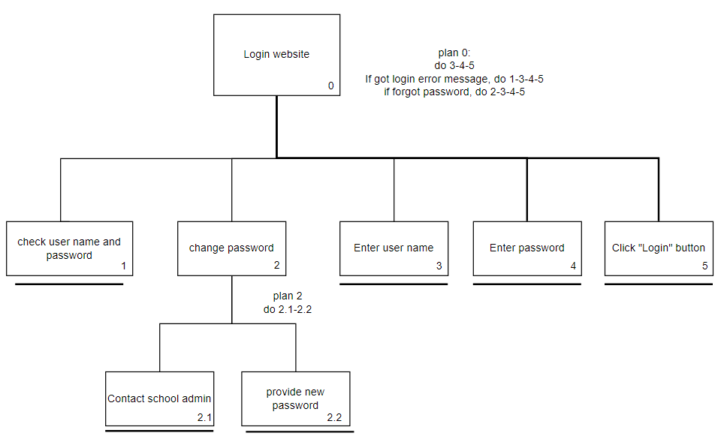

Navigate the website:

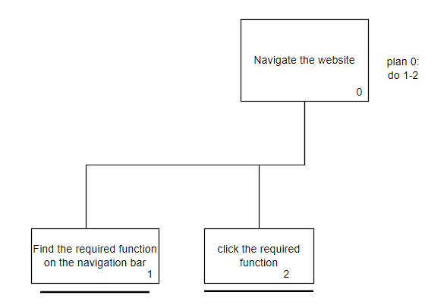

Major Functions of the System:

**1. Account Management**

1. School Admin
   1. View and search **ALL** user information

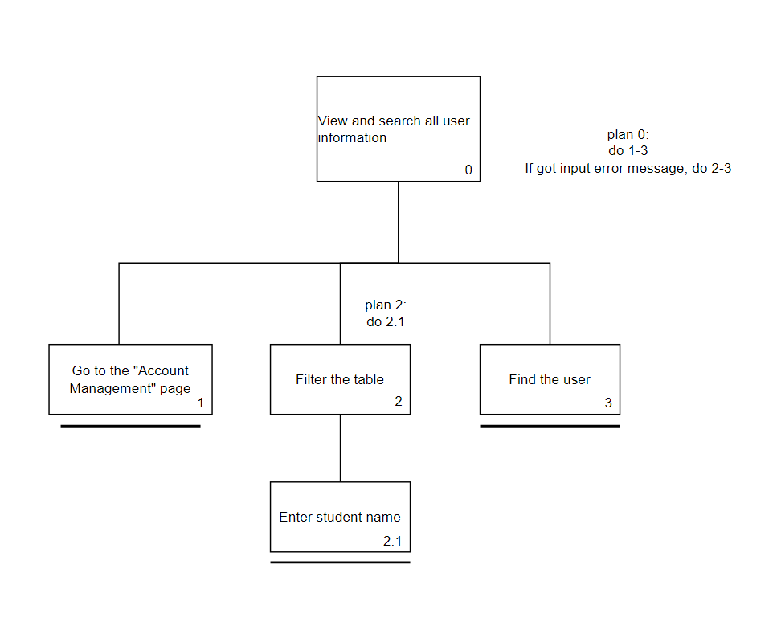

* 1. Create accounts for all the school members

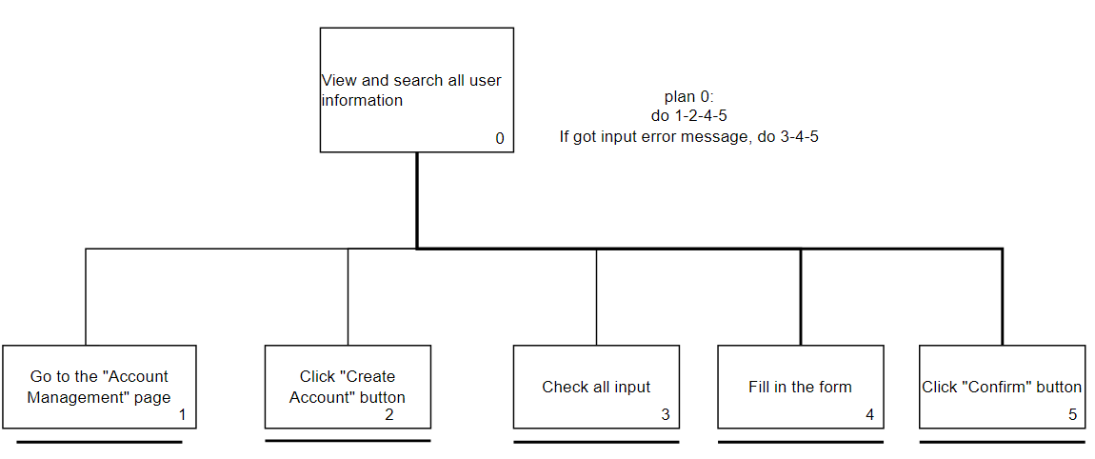

* 1. Enable/ Disable user accounts

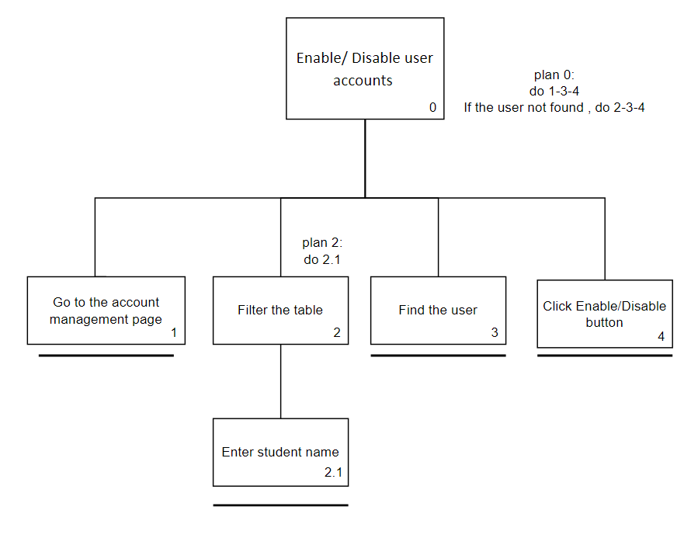

1. Class Teacher
   1. Search, Edit, and View student information in their Class

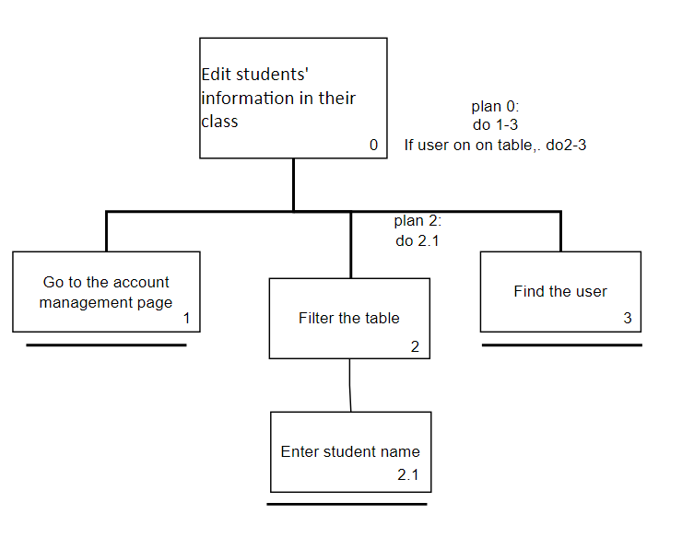

* 1. View and edit personal account information, including change password

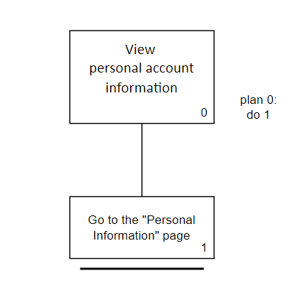

(view personal account)

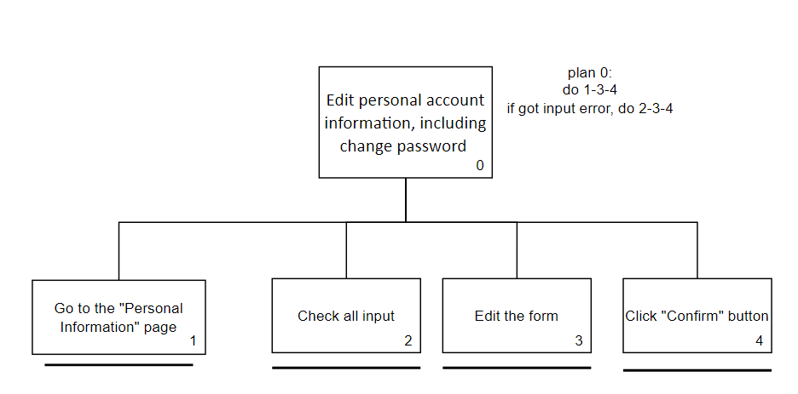

(Edit personal account)

Student

1. View and edit personal detail, including change password



(View personal account)



(Edit personal account)

**2. Class allocation:**

1. Class Teacher
   1. Create Class

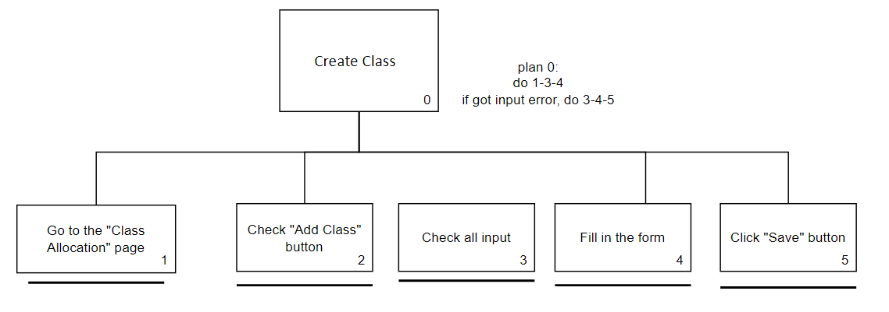

(Create class)

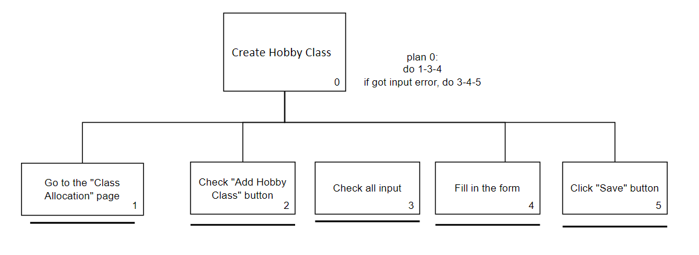

(Create hobby class)

* 1. Edit Class information

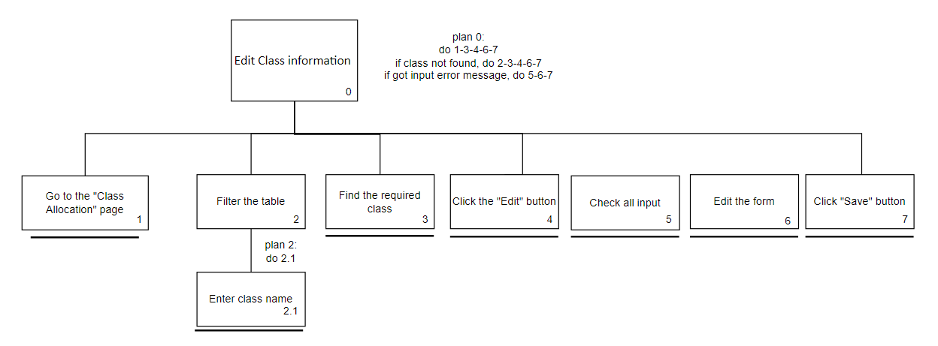

* 1. Add/Drop students to their class

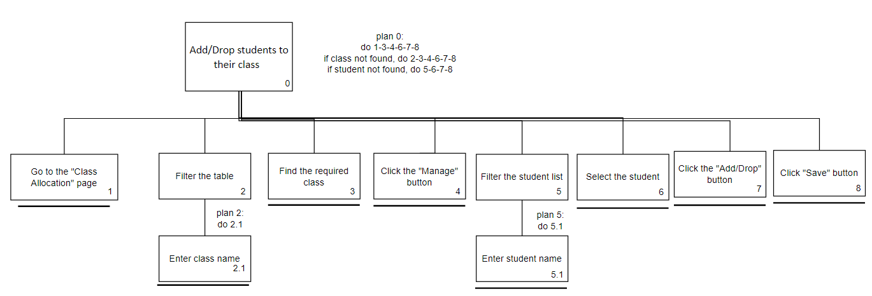

* 1. View Class detail



* 1. View Student list

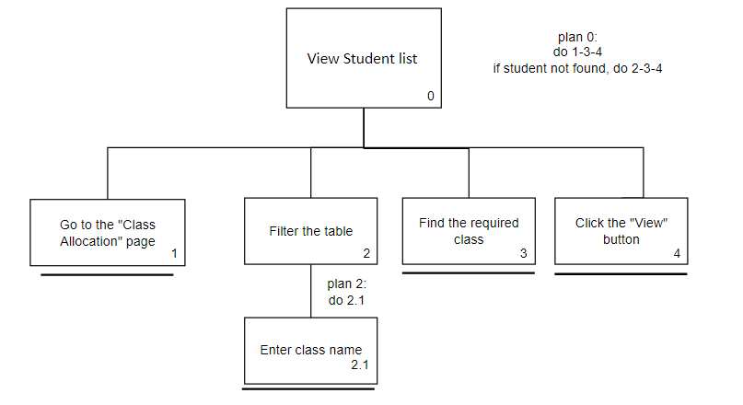

1. School Admin

1.Set the Classes Archive to allow new Classes creation

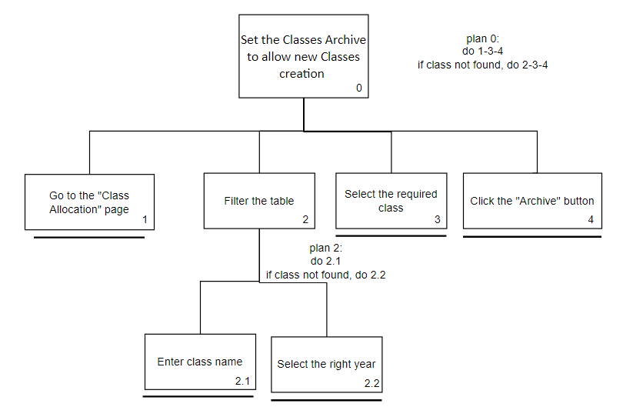

(Set class archive-style 1)

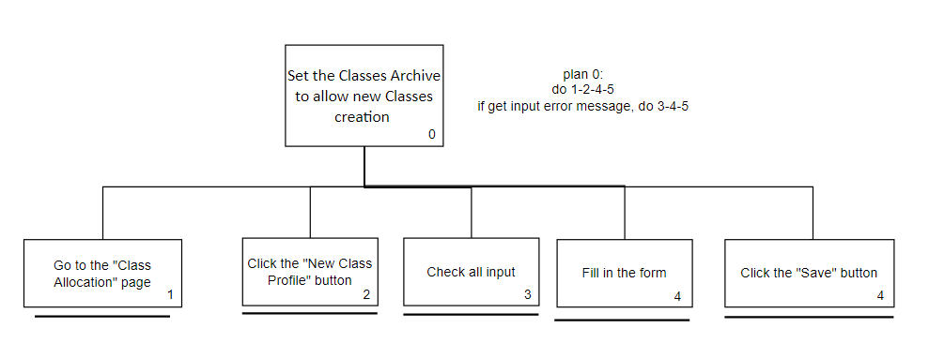

(Set class archive-style 2)

2.Edit Class information

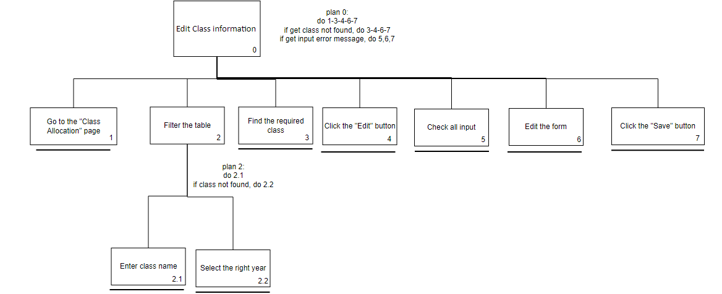

1. Student

1.View their Class allocation status (including current year and previous years)

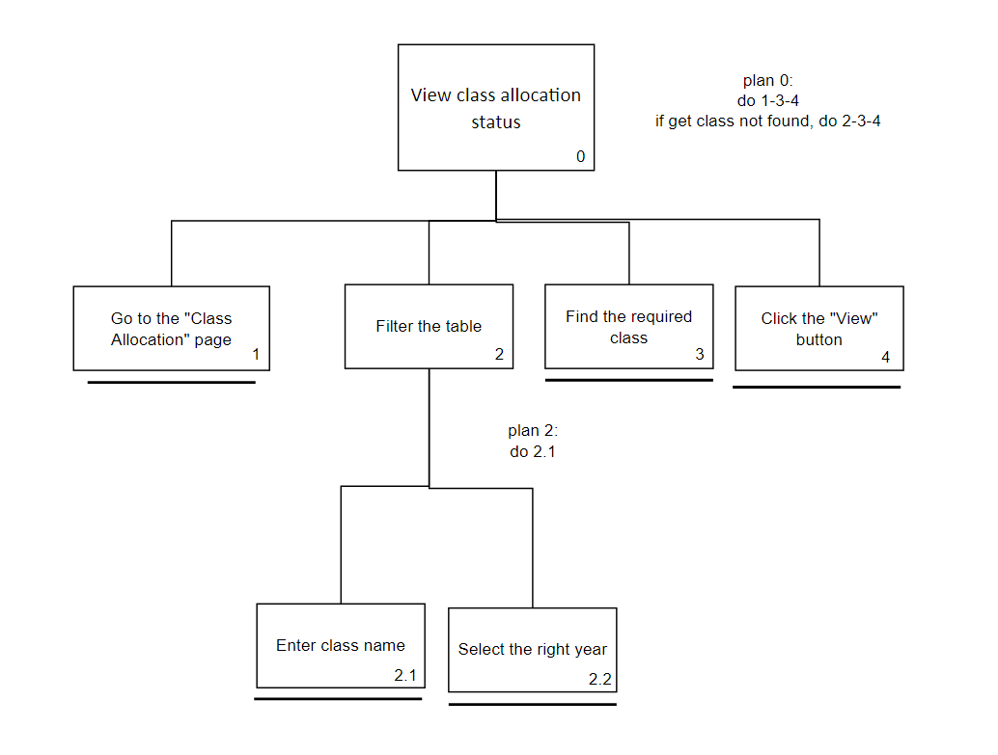

**3. Searching & reporting:**

1. Student
   1. Search their attendance records by year, month, etc.

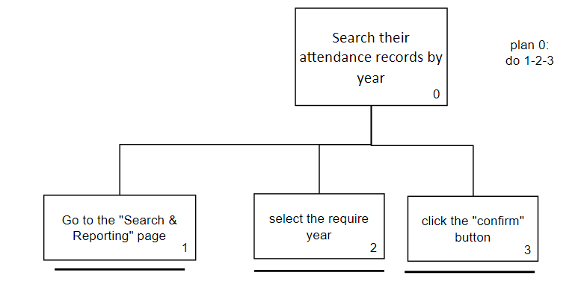

(Search attendance by year)

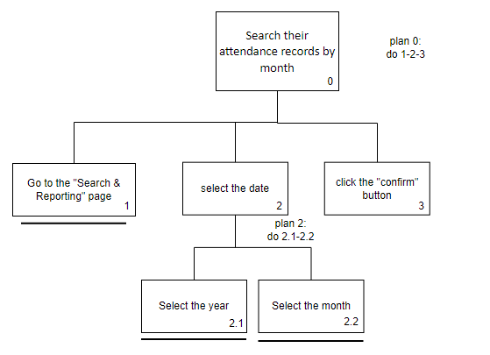

(Search attendance by month)

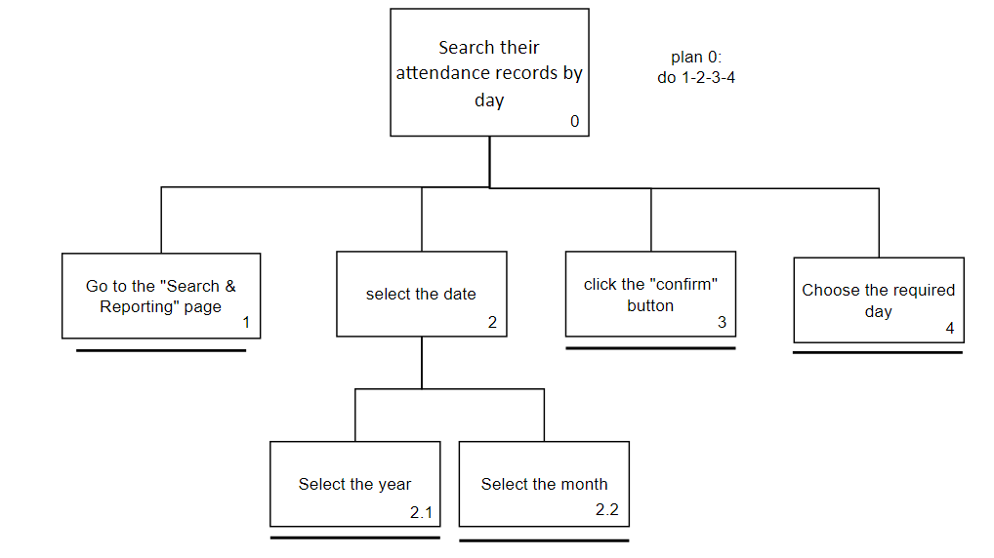

(Search attendance by day)

1. Class Teacher

Search students’ attendance record as a class and an individual student in the current year.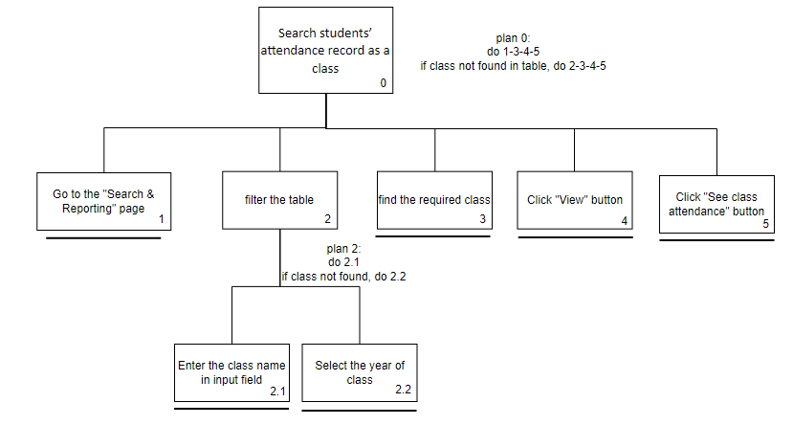

(Search attendance record as a class)

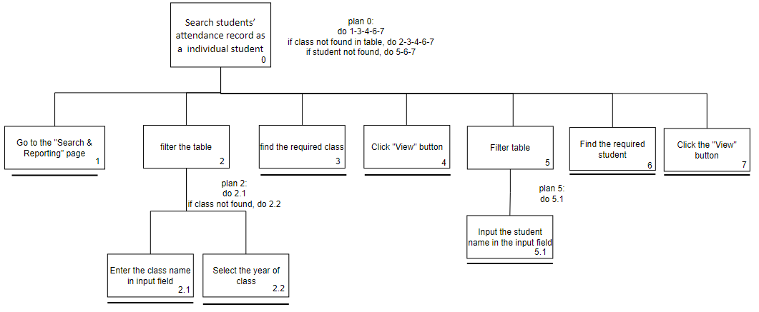

(Search attendance record as a single student)

* 1. Generate class reports for the attendance record, absent record, sick leave record, late record, etc.

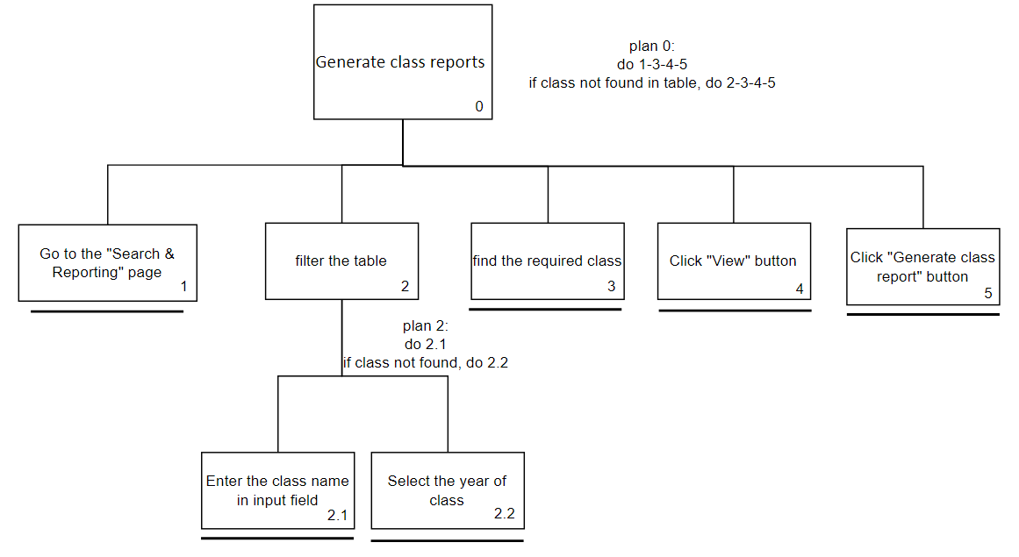

1. School Admin

1.Search current students’ attendance record as a school, class, and an individual

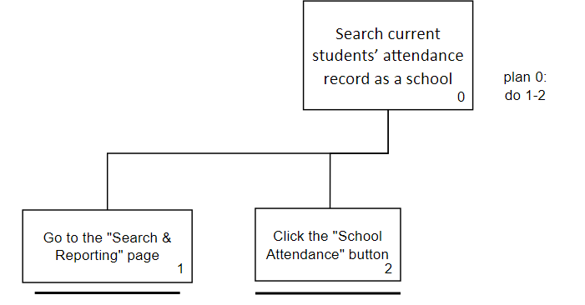

(Search attendance as a school)

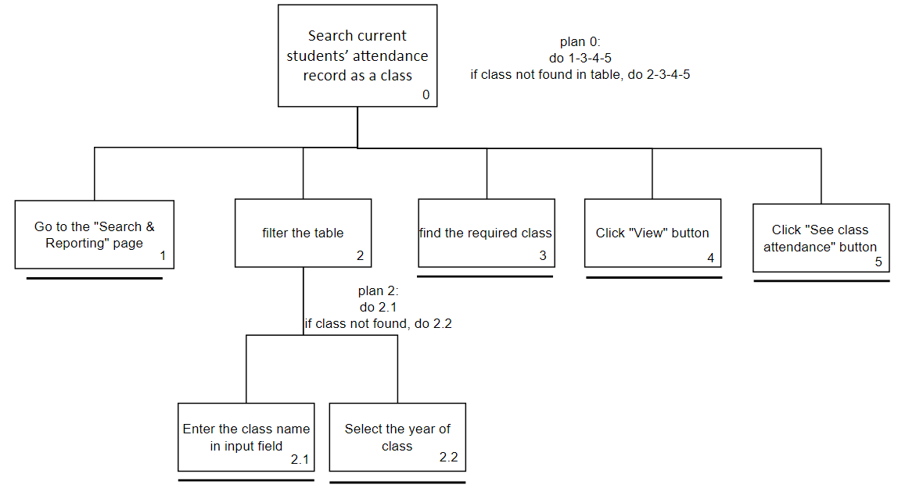

(Search attendance as a class)

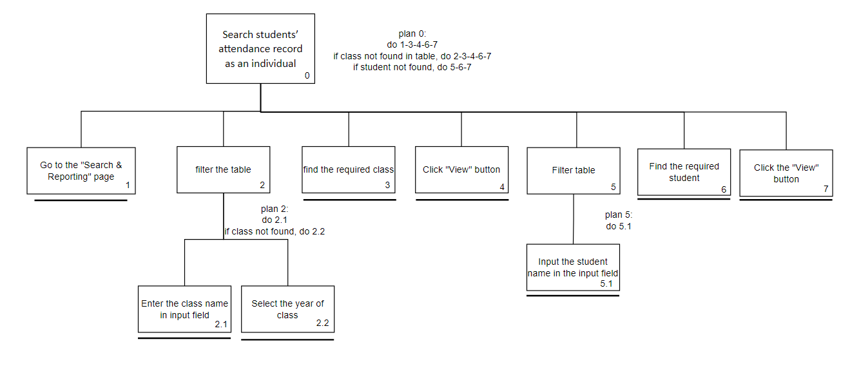

(Search attendance as a single student)

2.Generate school reports for the attendance rate, absents record, sick leave record, late record, etc, for the current school year

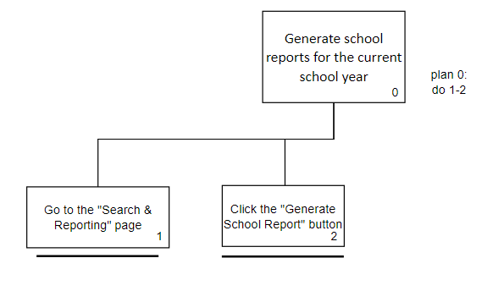

* 1. Generate the above reports for previous years

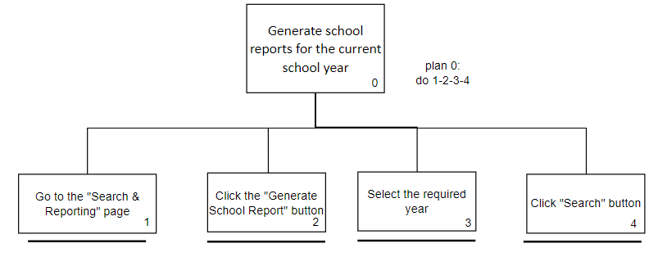

**4. Attendance Management:**

School Admin

1. Tick attendance

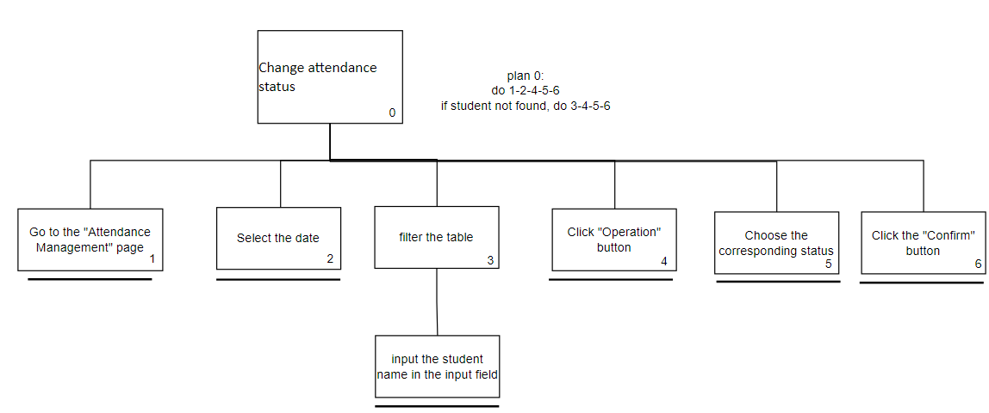

2.Endorse Sick Leave Letter

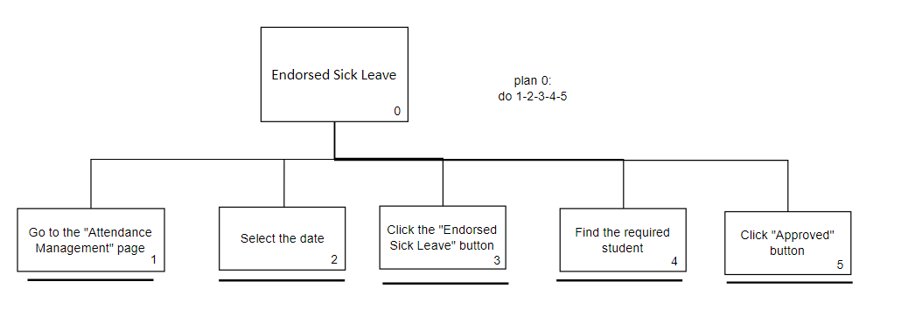

Student

1.Upload sick leave certificate and leave letter

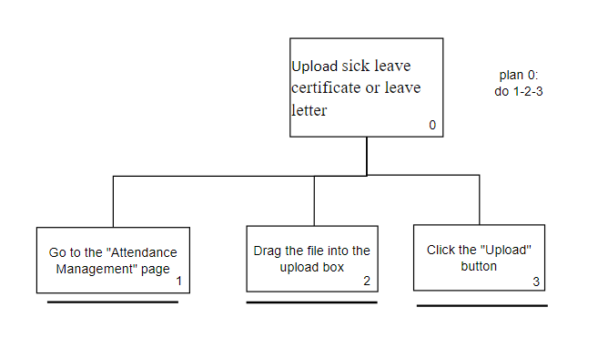

2.See sick leave or leave approve status

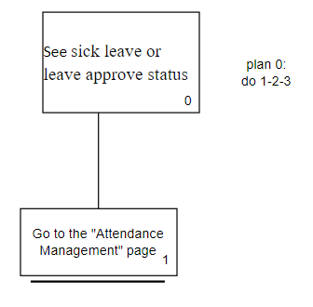

Admin

1.Mark sick leave status

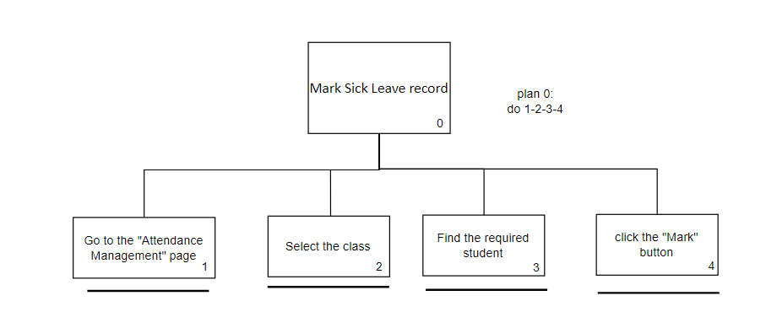

**Learning Center**

Student

1.Answer test

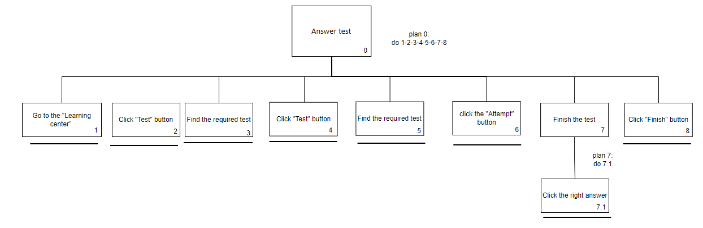

2.Review test

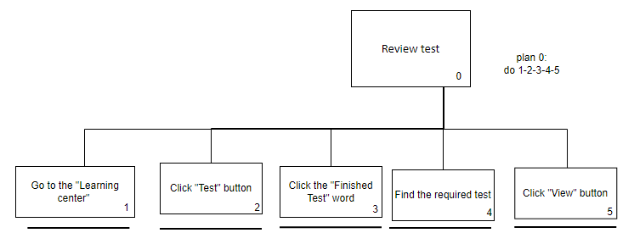

3. View learning material

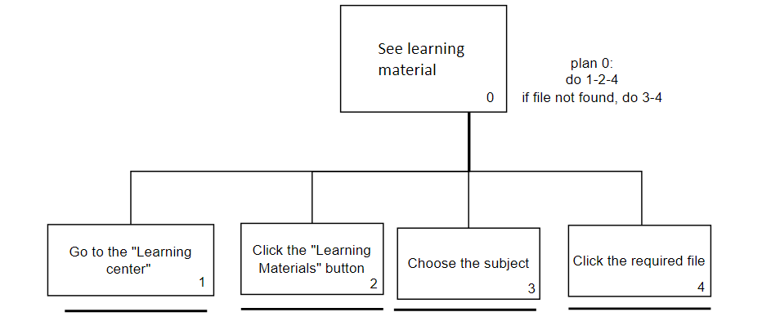

4.Use learning tools

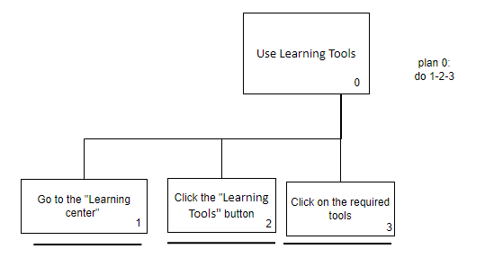

Admin

1.See center overview

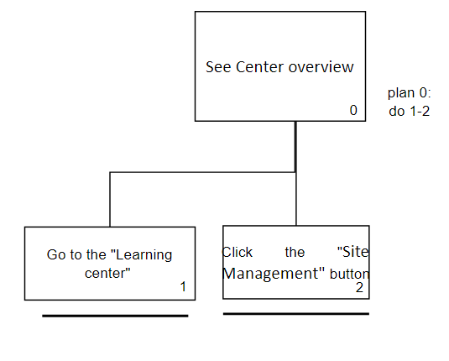

2.See site report

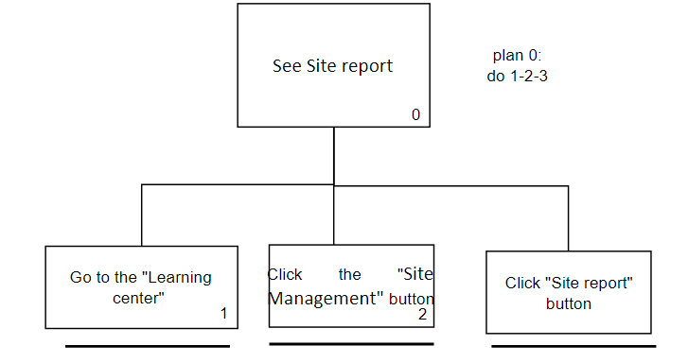

3.Edit center setting

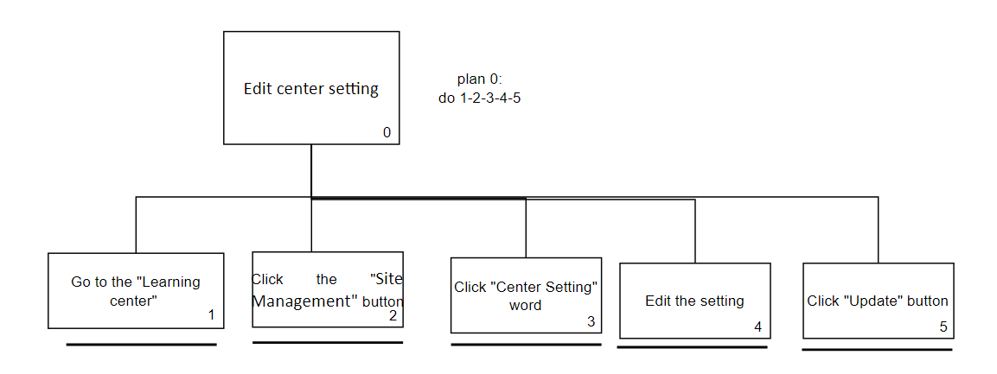

4.Manage Learning Materials of a class

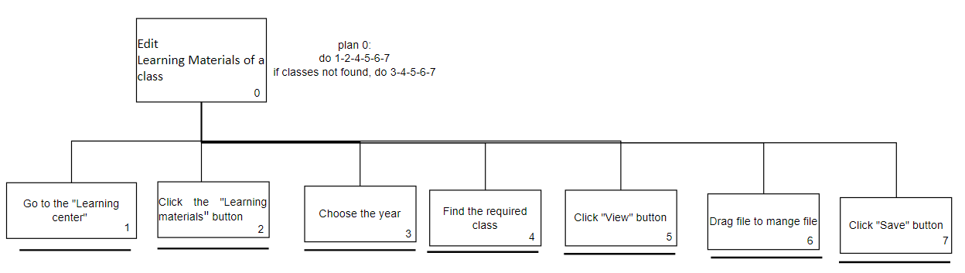

5.Manage Learning tools

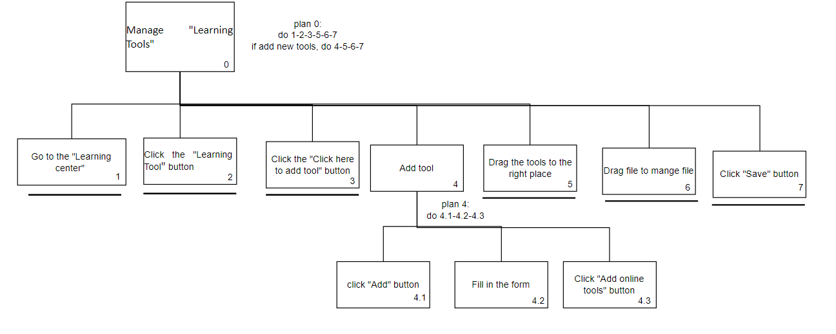

5.Use Learning tools



Teacher

1.Create test

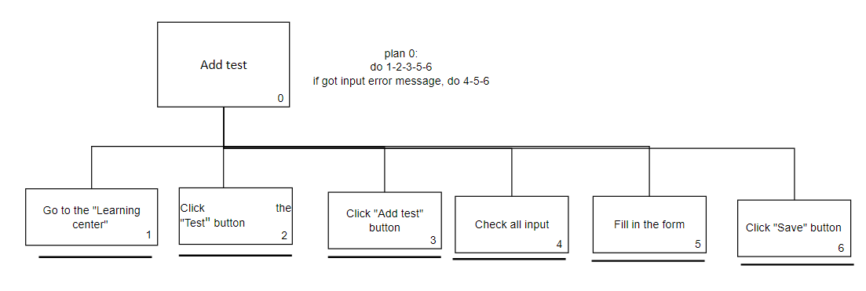

2.View existing test status

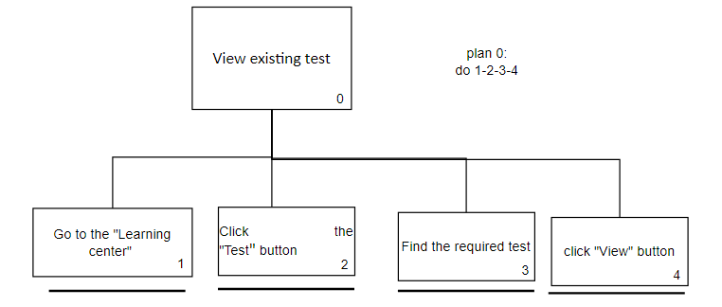

3. Close existing test

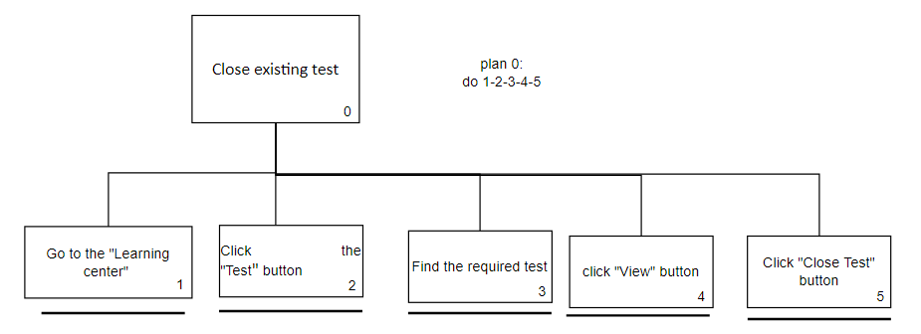

4.Review finished test

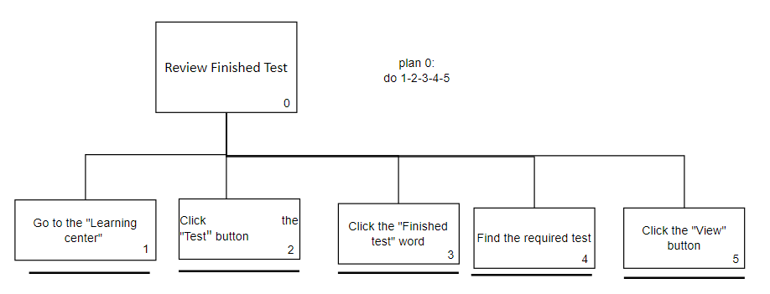

5. View learning materials

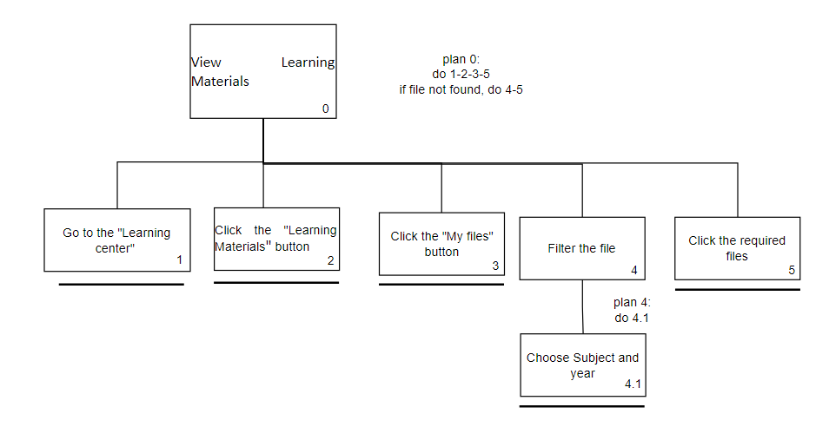

6.Delete Learning Materials

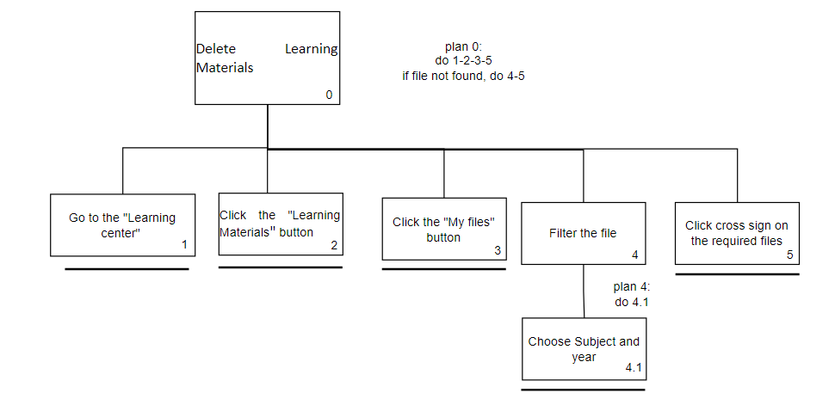

7. Upload learning materials

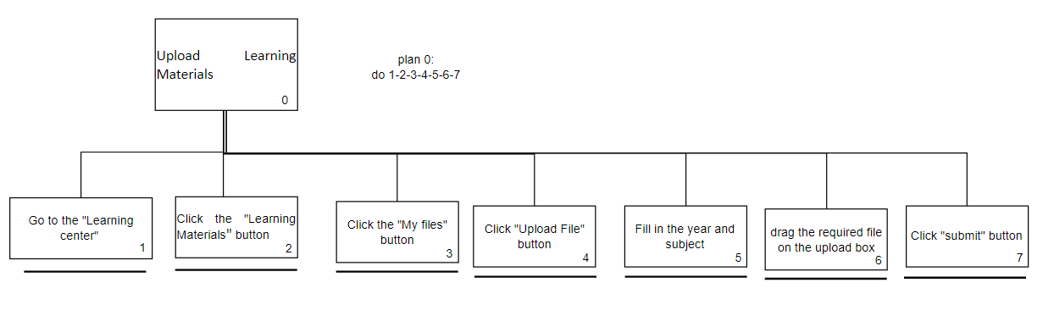

8.Assign learning materials to students

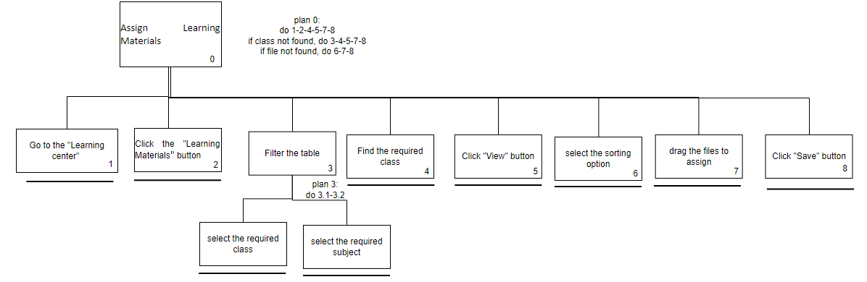

9.Use learning tools



# Mental Model

## 一張含有 文字, 個人, 室內 的圖片 自動產生的描述Login Page

The user will be using the login page to doing the login operation, this operation will include the role of Admin, class teacher and student.

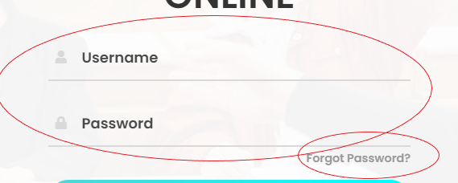Webpage have following Mental Model:

* complete login

1. enter correct Username and Password
2. click “login” button
3. Login success

* Forget password

1. Click “forget password”
2. Send forget password message

## 一張含有 文字 的圖片 自動產生的描述Home page

Home page is use for displaying the news of the school or give the give notice to users.

Webpage have following Mental Model:

* Move to other page

1. Move to navigation bar
2. Click navigation bar item
3. Move success

* Change displayed news

1. Move to turn left/ turn right button
2. Click button
3. change success

## Admin

### Account Management

Webpage have following Mental Model:

* 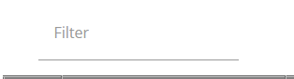View and search all user information

1. Move to the filter column
2. Enter keyword
3. Show filtered table

* Graphical user interface

  Description automatically generated with medium confidencecreate accounts for all the school members

1. Click “create account” button
2. Enter account information (username, email address, role)
3. click “confirm”
4. create success

* Enable/ Disable user accounts

1. Move to appropriate account record
2. Click Enable/ Disable checkbox
3. Enable/ Disable success

* Get notice of webpage

1. Move to the notice logo and hover
2. A picture containing graphical user interface

   Description automatically generatedText

   Description automatically generated with low confidenceNotice display

* Chart, timeline, bar chart

  Description automatically generatedTable

  Description automatically generatedChange account role

1. Move to appropriate account record
2. Click drop-down list
3. Change success

* Table

  Description automatically generatedAscending/ descending record

1. Click top of column
2. Ascending/ descending record success

* Change table page

1. Click drop down list under table
2. Select appropriate number
3. Change success

### Class Allocation

Webpage have following Mental Model:

* Set the Classes Archive/Cancel/Active
  1. Click at least one class’s checkbox
  2. Click the status that want to change
  3. Change success

* new Classes creation
  1. click “add class” button
  2. select class, classroom and lesson set
  3. click “save”
  4. create complete

* Edit Class information
  1. Move to appropriate class record
  2. Click “edit”
  3. When complete edit, click “save”
  4. Edit complete

* Timeline

  Description automatically generated with medium confidenceModify new class profile
  1. Click “new class profile”
  2. Select information
  3. Click “save”
  4. Modify success
* Graphical user interface

  Description automatically generatedView class detail
  1. Graphical user interface, table

     Description automatically generatedMove to appropriate class record
  2. Click “view”
  3. View success

* Manage class student
  1. Move to appropriate class record
  2. Click “manage”
  3. Move student name to appropriate class
  4. Click “save”
  5. Manage success

### Searching & reporting

Webpage have following Mental Model:

* Search students’ attendance record as school
  1. Click “school attendance”
  2. Table

     Description automatically generated with low confidenceSearch success

* Search students’ attendance record as class
  1. Move to appropriate class record
  2. Click “view”
  3. Graphical user interface, text, application, chat or text message

     Description automatically generatedClick “see class attendance”
  4. Search success

* Graphical user interface

  Description automatically generatedSearch students’ attendance record as individual
  1. Click “search individual attendance”
  2. Enter student name to search student record
  3. Click “view” when search success
  4. View individual attendance success

* Search students’ attendance record from class as individual
  1. Move to appropriate class record
  2. Move to appropriate student record
  3. Click “view”
  4. A picture containing chart

     Description automatically generatedSearch success

* Generate school reports
  1. Click “generate school report”
  2. Select generate year
  3. Generate success

* Graphical user interface, application

  Description automatically generatedGenerate the above reports for previous years
  1. Click “generate school report”
  2. Select generate year
  3. Generate success
* A picture containing timeline

  Description automatically generatedGenerate class report
  1. Move to appropriate class record
  2. Click “view”
  3. Click “generate class report”
  4. Graphical user interface, text, application, chat or text message

     Description automatically generatedGenerate success

### Attendance Management

Webpage have following Mental Model:

* Mark Sick Leave record
  1. Select appropriate class
  2. Click “confirm”
  3. Mark success

Learning Center

Webpage have following Mental Model:

* Generate site report
  1. Click “site Management”
  2. Click “center overview”
  3. Click “site report”
  4. Generate success

* Update learning center page setting
  1. Click “site Management”
  2. Click “center setting”
  3. Timeline

     Description automatically generated with medium confidenceUpdate information
  4. Click “update to confirm setting”
  5. Update success
* Update learning material
  1. Update learning material
  2. Diagram

     Description automatically generatedSelect year and move to appropriate class
  3. Click “view”
  4. Graphical user interface

     Description automatically generatedUpdate material
  5. Click “save”
  6. Update success



* View online tools
  1. Graphical user interface

     Description automatically generatedClick “learning tools”
  2. View success

* Modify online tools
  1. Click “learning tools”
  2. Click “click here to add tools”
  3. Modify tools (add, delete and change tools category)
  4. Click “save”
  5. Graphical user interface, text, application

     Description automatically generatedModify success

## Student

### Account Management

Webpage have following Mental Model:

* View and edit personal detail
  1. Modify personal data
  2. Click “confirm”
  3. Edit “success”

### Class Allocation

Webpage have following Mental Model:

* View Class allocation status
  1. Move to appropriate class record
  2. Click “view”
  3. Table

     Description automatically generatedView success

### Searching and reporting

Webpage have following Mental Model:

* Search year attendance record
  1. Select correct year
  2. Click “confirm”
  3. Search success

* Search month attendance record
  1. Select correct year and month
  2. Click “confirm”
  3. Search success

* Graphical user interface, application

  Description automatically generatedSearch day attendance record
  1. Select correct year and month
  2. Click “confirm”
  3. Click day in the calendar
  4. Search success

### Attendance Management

Webpage have following Mental Model:

* Upload sick leave certificate/leave letter
  1. Drag &Drop file or click “upload” button
  2. Select submission type (certificate or leave letter)
  3. Click “confirm”
  4. Upload success

### Learning center

Webpage have following Mental Model:

* Test Attempt
  1. Click “Test” button
  2. Click sub-title “Test”
  3. Move to appropriate test and click “attempt”
  4. Table

     Description automatically generated with low confidenceSuccess to test attempt

* Text

  Description automatically generated with low confidenceView Finished Test
  1. Click “Test” button
  2. Click sub-title “Finished Test”
  3. A picture containing graphical user interface

     Description automatically generatedMove to appropriate test and click “view”
  4. View success

* View Learning material
  1. Click “Learning materials” button
  2. Graphical user interface, application

     Description automatically generatedClick “appropriate material”
  3. View success

* View Learning tools
  1. Click “learning tools” button
  2. Click appropriate hyperlink
  3. Online Tools access success

## Teacher

### Account management

Webpage have following Mental Model:

* Search and View student information in their Class
  1. Enter keyword in filter column
  2. Show filtered table

* Edit student information in their Class
  1. Move to appropriate student record
  2. Click “edit”
  3. Update student information
  4. Click “confirm”
  5. Edit success

* A picture containing text

  Description automatically generatedView and edit personal account information
  1. Click teacher profile icon
  2. Modify personal data
  3. Click “confirm”
  4. Edit success

### Class Allocation

Webpage have following Mental Model:

* Diagram

  Description automatically generatedCreate Class
  1. Click “Add Class”
  2. Select class information
  3. Click “save”
  4. Create success

* Graphical user interface

  Description automatically generatedEdit Class information
  1. Move to target record
  2. Click “edit”
  3. Edit information
  4. Graphical user interface, application

     Description automatically generatedClick “save”
  5. Edit success

* Add/Drop students to their class
  1. Move to target record
  2. A screenshot of a computer

     Description automatically generated with medium confidenceClick “Manage”
  3. Add/drop students
  4. Click “save”
  5. success to manage class’s students



* Graphical user interface

  Description automatically generatedView Student list and Class detail
  1. Move to target record
  2. Click “view”
  3. View success

### Searching and Reporting

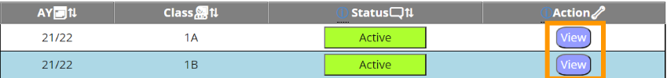Webpage have following Mental Model:

* Search students’ attendance record as a class
  1. Move to target class record
  2. Table

     Description automatically generatedClick “view”
  3. Move to target student record
  4. Click “view”
  5. Search success

* Graphical user interface

  Description automatically generated with low confidenceSearch students’ attendance record as an individual student
  1. Click “search individual attendance”
  2. Enter correct student name and search
  3. Table

     Description automatically generatedMove to target student record
  4. Click “view”
* Print students’ attendance record as a class
  1. Move to target class record
  2. Click “view”
  3. Move to target student record
  4. Table

     Description automatically generatedClick “view”
  5. Click print
  6. Print success



* Generate class reports
  1. Move to target class record
  2. Graphical user interface

     Description automatically generatedClick “view”
  3. Click “generate class report”
  4. Generate success

### Attendance Management

Webpage have following Mental Model:

* Tick attendance
  1. Move to target student record
  2. Click operation icon
  3. Modify the attendance status
  4. Click “confirm”
  5. Modify attendance record complete
* A picture containing shape

  Description automatically generatedEndorsed sick leave
  1. Click “endorsed sick leave”
  2. Move to target student sick leave record
  3. Check sick leave record
  4. Click “approved”
  5. Table

     Description automatically generatedSick leave approved

### Graphical user interface, application Description automatically generatedLearning center

Webpage have following Mental Model:

* Logo

  Description automatically generated with medium confidenceAdd test
  1. Click “test” button
  2. Click sub-title “test”
  3. Click “add test”
  4. Graphical user interface

     Description automatically generatedInsert test details
  5. Click “save”
  6. Add test complete

* Graphical user interface, application

  Description automatically generatedNotice student to complete test
  1. Click “test” button
  2. Click sub-title “test”
  3. Logo

     Description automatically generated with medium confidenceMove to target test record and click view
  4. Click “notice them via school mail”

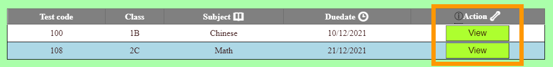

* Close test
  1. Click “test” button
  2. Click sub-title “test”
  3. Move to target test record and click view
  4. Click “close test”



* Graphical user interface, application

  Description automatically generatedView and download test content of finished test
  1. Click “test” button
  2. Click sub-title “finished test”
  3. Move to target test record and click “view”
  4. Click “download result report” or “download student result”
  5. Shape, rectangle

     Description automatically generatedDownload success

* delete leaning material
  1. Click “learning material”
  2. Click “my file”
  3. Graphical user interface

     Description automatically generatedClick delete icon
  4. Delete success

* A picture containing shape

  Description automatically generatedUpload leaning material
  1. Click “learning material”
  2. Click “my file”
  3. Graphical user interface

     Description automatically generatedClick “upload file”
  4. Upload file
  5. Click “submit”
  6. Upload success

* Modify student’s learning material
  1. Click “learning material”
  2. Move to target record and click “view”
  3. Table

     Description automatically generatedModify student’s learning material.
  4. Click “save”

* View online tools
  1. Click “learning tools”
  2. View success

# Affordance

## Login Page

* 一張含有 文字 的圖片

  自動產生的描述There are icons, column names and underscores (See Figure 3) to let users know that there is a user name input area and let them input account information.
* 一張含有 文字, 白板 的圖片

  自動產生的描述In addition, when the user clicks on the column, the column will be expanded (See Figure 4), and user will be allowed to enter account information.
* “Forget password” and “login” button will change background color when the user is hover in the button area.

|  |  |
| --- | --- |
| Non-hover | hover |
|  |  |
|  |  |

## Home page

* 一張含有 文字 的圖片

  自動產生的描述一張含有 文字 的圖片

  自動產生的描述There are left and right buttons, and user can use it to change displayed information.
* Regarding the navigation bar, the website uses icons to indicate functions. For example, the logout function is represented by the leave sign.
* 一張含有 文字 的圖片

  自動產生的描述Website’s navigation bar have using yellow background color and blue color text displayed that your current website.
* when hover in the navigation bar item, the item’s text will change to red color

## Admin

### Account Management

* 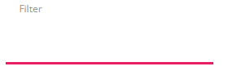When clicked, the filter will expand to allow the entry of keywords, and the underline will change to red
* 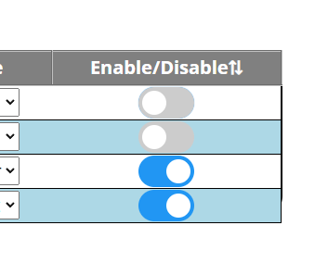enable or disable check box use gray represent disable, blue represent enable
* 一張含有 桌 的圖片

  自動產生的描述The account creation form will have placeholders to inform the user to enter account information.

### Class Allocation

* 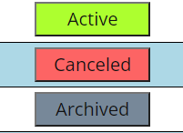Status archive, cancel and Active use different color to represent (Archived is grey, cancel is red, Active is green)

* 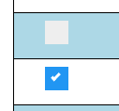 Checkbox will use blue background color and white font color to represent checked, use grey background color represent non-checked.

### Searching & reporting

* The button will have icon in front of the button name, it can easier represent the function to the user

### Attendance Management

* 一張含有 文字 的圖片

  自動產生的描述admin will using drop-down list to select the class for which sick leave records need to be marked.

### Learning Center

* Hover buttons will change button size, font size and font color.

|  |  |
| --- | --- |
| normal | hover |
|  |  |

* Hover the mouse over the pie chart and line chart, it will show statistics.

|  |  |  |
| --- | --- | --- |
|  |  |  |

* 一張含有 文字 的圖片

  自動產生的描述The web page will use "+" and "-" to display the status of the sub-pages, "+" means the sub-page is collapsed, and "-" means the sub-page is expanded
* Use blue range bar to let user modify webpage setting.
* 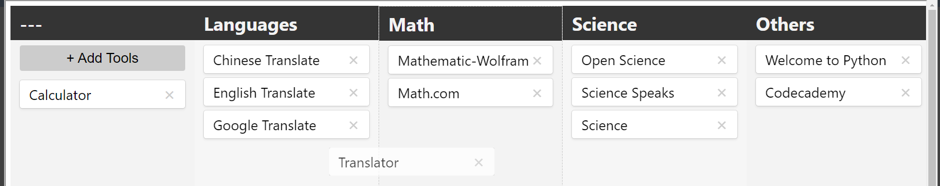The online tool block uses a white background color, allowing category to be changed by dragging and dropping.

* All hyperlinks are in purple, which makes it easier for users to identify them.

## Student

### Account Management

* 一張含有 文字 的圖片

  自動產生的描述The form column are curved, allowing users to identify every part of the form.

### 一張含有 文字 的圖片 自動產生的描述Class Allocation

* Student will click “view” to watch their class allocation status

### Searching and reporting

* 一張含有 文字 的圖片

  自動產生的描述 The user can click the confirm button to query the attendance record of the year, month and day.
* 一張含有 文字 的圖片

  自動產生的描述Users can click on the monthly calendar date to query the attendance record details of the day

### Attendance Management

* 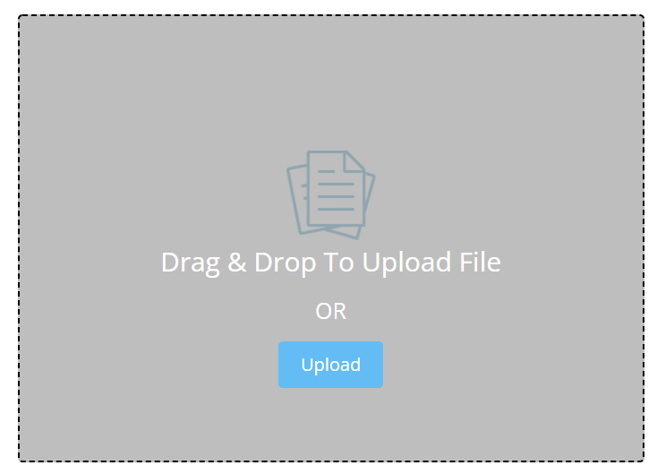Have drag and drop area/upload button to let student upload the file
* 一張含有 文字 的圖片

  自動產生的描述Have confirm button to let student confirm file information and upload file to the server.

### Learning center

* 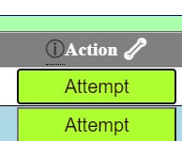Student can click attempt button to complete the test
* 一張含有 文字 的圖片

  自動產生的描述Student can click view button to doing past test review
* 一張含有 文字 的圖片

  自動產生的描述Student can click learning material’s icon to access relevant material.
* 一張含有 文字 的圖片

  自動產生的描述Students can click on the hyperlinks of learning tools to enter different categories of web pages

## Teacher

### Account management

* Teachers can input keywords in the filter column to filter table data.
* 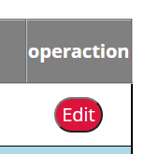Teacher can click edit to modify student’s personal data
* Teacher can click teacher profile icon to modify his//her personal data

### Class Allocation

* 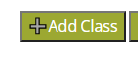Teacher can click add class to create a new class
* Teacher can click edit to modify class’s information
* Teachers can click Manage to insert or delete students in the list of class student.
* 一張含有 文字 的圖片

  自動產生的描述Teacher can click view to looks class details and the list of students.

### Searching and Reporting

* 一張含有 文字 的圖片

  自動產生的描述Teacher can click view button to watch class student’s individual attendance
* Teacher can click search individual attendance button to watch student’s individual attendance
* 一張含有 文字, 監視器, 時鐘 的圖片

  自動產生的描述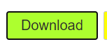Teachers can click the print or download button to print attendance records and reports



* Teachers can click generate class report button to generate class report.

### Attendance Management

* 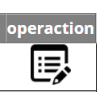Teacher can click the operation icon to modify the student's attendance status.
* 一張含有 文字 的圖片

  自動產生的描述Teacher can click endorsed sick leave button to approved student’s sick leave

### Learning center

* 一張含有 文字, 美工圖案 的圖片

  自動產生的描述Teachers can click “Add Test” to create a new test for students
* 一張含有 文字 的圖片

  自動產生的描述Teachers can click “notice them via school mail” to send the notification to students
* Teachers can click "Close Test" to change the test status to finished.
* 一張含有 文字 的圖片

  自動產生的描述Teachers can click “download result report” or “download student result” to download content of finished test.
* 一張含有 文字 的圖片

  自動產生的描述Teachers can click the delete icon to delete inappropriate learning materials.



* Teachers can click "Upload File" to upload new materials to the server
* 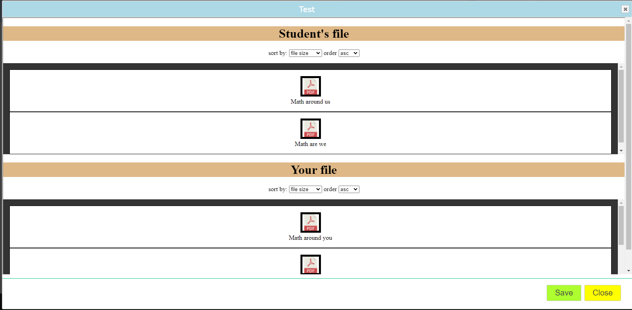Teachers can click "View" in the "Learning Materials" dialog box to modify students' learning materials

* Teachers can click "Learning Tools" to view the hyperlinks of the latest online tool.

# Content Organization

## Organizational schemes

The website uses a task-oriented organization scheme to group projects into their own goals to organize projects.

This method enables the user to easily find the function he or she wants.

For example, if the teacher wants to change the student's attendance record, just click on the attendance management button. And then go to the attendance page to change attendance.

## Organizational structures

The website has using Hierarchy structure, which is structure by rank or level.

That is the example of the admin interface:

## Research and interview techniques

Before creating the website, the development team used Card Sorting to group all functions. For example, according to the card Sorting results, the user classifies the "View and Search All User Information" and "Create Account for All School Members" cards into the same category. Therefore, when the development team implements them, they are classified under the category of "Customer Management"

# Visual Organization

## Proximity

* 一張含有 文字 的圖片

  自動產生的描述Regarding Proximity, the website divides content into three parts (header, body and footer). So that the content can easily attract users' attention.

## Alignment

* 一張含有 桌 的圖片

  自動產生的描述With regard to alignment, the website has been aligned to two ways (center and left alignment). For example, for the title, the website aligns it to the center, which makes it more eye-catching. For content (button), it is aligned to the left, which looks neat.

## Consistency

About the consistency, we have doing following operation:

* Repeating alignment scheme
  + In the other web page on the website, it is also aligned to the title to center and button to left.

|  |  |
| --- | --- |
|  |  |

* Placing navigation tools, like site links, in the same position
  + 一張含有 文字 的圖片

    自動產生的描述As for the title of the website, the website put it in the same place for the web page. It makes users not to confuse about the title of each web page. In addition, the title also has a locking position on the web page.
* Using the same style

|  |  |
| --- | --- |
| Teacher – Class allocation | Teacher - Searching & reporting |
|  |  |

* + The web page have using same CSS file and let each categories have same style, for example font size, color, background and table.

## Contrast

* 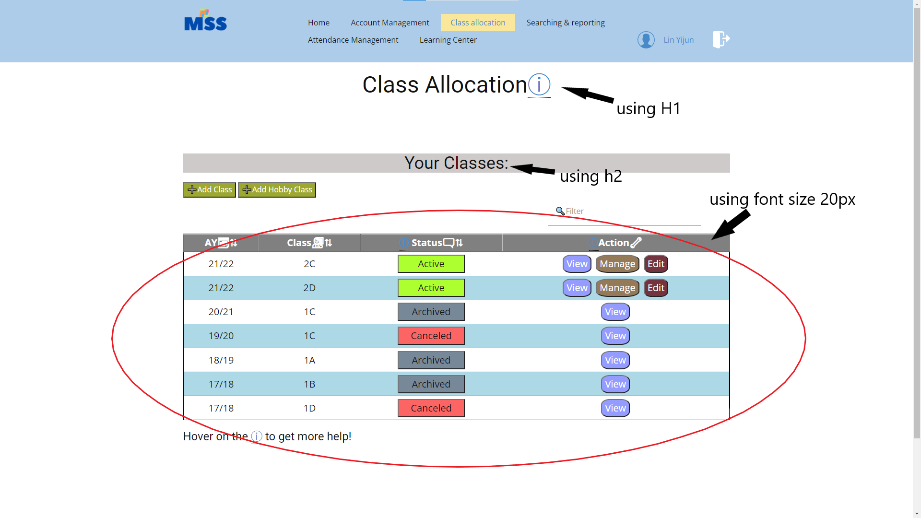Regarding the content, title and subtitle, webpage use different font colors and font sizes to highlight the content of the title and subtitle. This makes it easier to attract the attention of users to the title.

# Navigation

## Navigational Design

The navigation system used in this website is hierarchical. As for this navigation system, its advantage is that when users use the website, it can facilitate them to move in the hierarchy, instead of going all the way to the top. Besides, it will be easier to maintain in the future.

There is the whole hierarchical design of the website:

## Navigational Elements

* 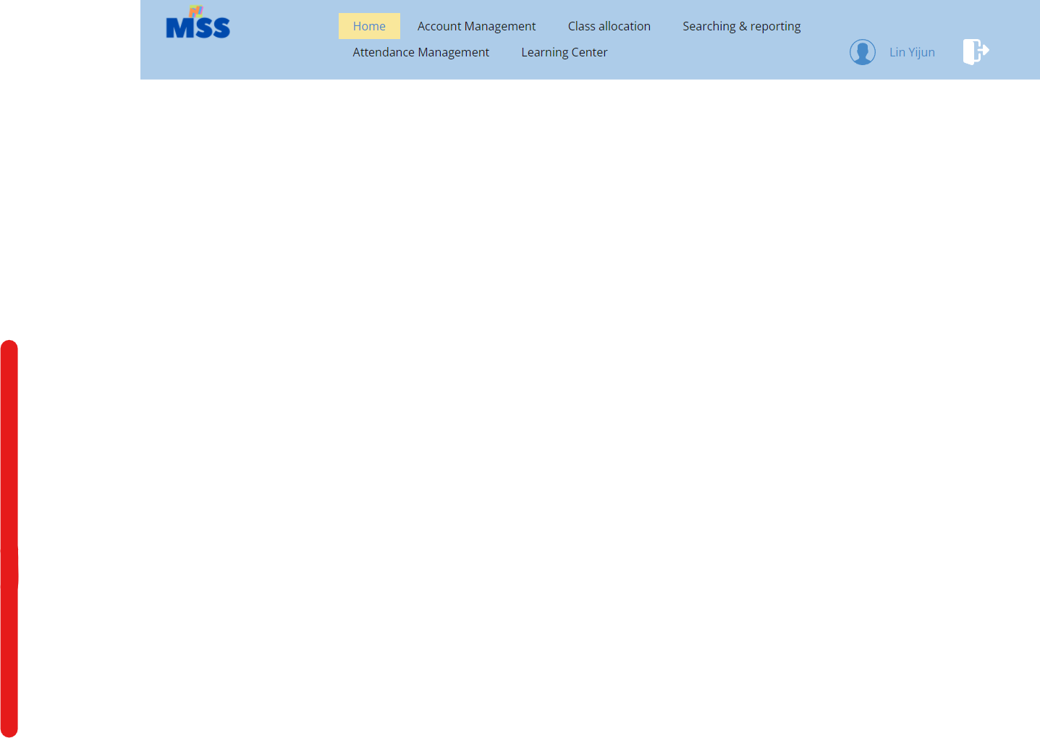website has using Navigation Bars on the top
  + standard icons
    -  In the navigation bar, the website uses person icons to represent personal information
    -  Use door to indicate the logout function